**DESIGN AND IMPLEMENTATION OF SMART HOME REMOTE MONITORING SYSTEM BASED ON ARM11**

**ABSTRACT**

Considering the disadvantage of smart home on wiring, maintainability and mobility, a scheme for remote monitoring of smart home is proposed based on ARM and ZigBee. Building home network based on ZigBee Technology, and then gateway is developed with S3C6410 which Linux operating system is embedded, using TD-LTE wireless terminal system as external network, so that the user could see the scene of the environment. Using ultra-low power consumption and fast ARM11 processor so that real-time monitoring data is more accurate. The system can be widely used to monitor the environmental data of hospitals, factories and other places. It has good development prospects.

**INTRODUCTION**

With the obvious improvement of people’s living standard, intelligent home environment has gradually attracted people's attention. Smart home refers to the use of advanced computer network communication technology, embedded technology and sensor control technology to combine various subsystems related to home life, through integrated management, to make home life more comfortable and safe. Smart home system can be divided into three parts: home network, home gateway and external network[2]. At present, in the design of the smart home control system, the home network is generally constructed using a wired connection method based on a bus and a power line. These connection methods all have the disadvantages of complicated wiring, corrosion of the line, inconvenient maintenance, and affecting the interior appearance.

**EXISTING SYSTEM**

With the rapid development of science and economy, people’s pursuit of comfortable life becomes higher and higher, so smart home monitoring system comes into being [1]. However, the cost of smart home is high at present, it is difficult for ordinary families to accept. But this existing system is complicated in connection and wiring and also for younger people and older people. And the cost of wiring and new device cost much more and not easy to operate.

**EXISTING SYSTEM DISADVANTAGE**

* Cost is high.
* Complicated circuit
* Complicated operation.
* Not easy for replacement

**PROPOSED SYSTEM**

Smart home controller is the core component of the smart home system, which is composed of ZigBee coordinator, GPRS module, touch screen and sound light alarm device. Smart home controller is the control center of the whole remote monitoring system, and its hardware core is the central processor. From the aspects of function, expansibility, operation system support and power consumption, the powerful ARM11 microprocessor is selected as the main processor. The man-machine interface adopts touch screen to display the state information of the home equipment and the information sent by the user's mobile phone, and the user can conveniently input the related commands to control the household equipment. The sound and light alarm device uses the red light flashing by the warning lamp and the shrill alarm sound of the buzzer, so as to realize the function of the warning user. The hardware structure of smart home controller. control of the module, to achieve SMS transceiver. The

ZigBee coordinator is responsible for building the ZigBee network and connecting all the monitoring modules to the network. After the successful establishment of the network, the environment monitoring information and alarm information from each monitoring module are collected, and data interaction is carried out with the ARM processor through the serial port. Smart home monitoring module is used to collect and test information and send it to the smart home controller. At the same time, it receives the control instructions from the smart home controller to realize the intelligent control of household appliances. The monitoring module is composed of main control module, environmental information detection module, security information detection module, home appliance control module and power supply module. Through the ZigBee coordinator module connected to the smart home controller, the wireless star ZigBee network is established in the indoor, so as to realize the indoor security and home appliances wireless ZigBee network control.

**BLOCK DIAGRAM**



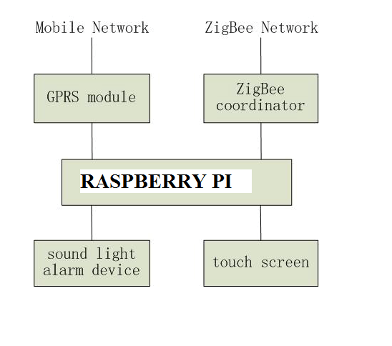

**HARDWARE REQUIREMENT**

* Raspberry pi
* Zigbee
* Screen
* Buzzer
* Relay
* GSM/GPRS
* Power Module

**SOFTWARE REQUIREMENT**

* Raspbian